**Hands-On: Stage 3 - Angular SPA-024 to SPA-026 - Day 72 – Hands on 5**

**Session - 1**

1. **Demonstrate using Service and HttpClient to invoke web service**

**user.component.html**

<div class="some">

    <input type="button"  value="Get Users"  (click)="retrieveAllUser()"/>&nbsp;

<br><br>

<table border="2"   cellspacing="0">

    <tr>

      <th>Photo</th>

      <th>Details</th>

    </tr>

    <tr  *ngFor="let item of user.data">

      <td><img  width="100" [src]="item.avatar"></td>

      <td style="text-align: left;">Name : {{item.first_name}} &nbsp;{{item.last_name}}

          <br>

          Email : {{item.email}}

    </td>

    </tr>

  </table>

</div>

**user.component.ts**

import { Component, OnInit } from '@angular/core';

import { UserService } from '../user.service';

import { user } from '../user.service';

@Component({

  selector: 'app-user',

  templateUrl: './user.component.html'

})

export class UserComponent implements OnInit {

  public user:any=[];

  constructor(private userService:UserService ) { }

  ngOnInit(): void {

  }

  retrieveAllUser() {

    this.userService.getAll()

      .subscribe(

        data => {

          this.user= data;

          console.log(data);

          console.log(this.user);

        },

        error => {

          console.log(error);

        });

  }

}

**user.service.ts**

import { Injectable } from '@angular/core';

import { HttpClient } from '@angular/common/http';

const baseUrl = 'https://reqres.in/api/users?page=2';

@Injectable({

  providedIn: 'root'

})

export class UserService {

  constructor(private http: HttpClient) { }

  getAll() {

    return this.http.get(baseUrl);

  }

}

//Interface for user to handle data

export interface user {

  id:number;

  email:string;

  first_name:string;

  last_name:string;

  avatar : string;

}

**app.module.ts**

import { NgModule } from '@angular/core';

import { BrowserModule } from '@angular/platform-browser';

import { AppRoutingModule } from './app-routing.module';

import { AppComponent } from './app.component';

import { ViewempsComponent } from './viewemps/viewemps.component';

import { EditEmpReactiveComponent } from './editemp/edit-emp-reactive.component';

import { EmployeeListComponent } from './employee-list/employee-list.component';

import { EmpInfoComponent } from './emp-info/emp-info.component';

import { UserComponent } from './user/user.component';

import {Routes,RouterModule} from '@angular/router'

import { viewClassName } from '@angular/compiler';

import { QuantityIncrementComponent } from './quantity-increment/quantity-increment.component';

import { FormsModule, ReactiveFormsModule } from '@angular/forms';

import { HttpClientModule } from '@angular/common/http';

const appRoutes:Routes=[{path:"" , component:ViewempsComponent},

  {path:"EditEmployees" ,

  component:EditEmpReactiveComponent},{path:"QuantityIncrement",component:QuantityIncrementComponent},

  { path: 'edit-emp-reactive/:id', component: EmployeeListComponent},{path:"User",component:UserComponent}]

@NgModule({

  declarations: [

    AppComponent,

    ViewempsComponent,

    EmployeeListComponent,

    EmpInfoComponent,

    UserComponent,

    EditEmpReactiveComponent,

    QuantityIncrementComponent,

  ],

  imports: [

    HttpClientModule,

    FormsModule,

    BrowserModule,

    AppRoutingModule,

    ReactiveFormsModule,

    RouterModule.forRoot(appRoutes)

  ],

  providers: [],

  bootstrap: [AppComponent]

})

export class AppModule { }

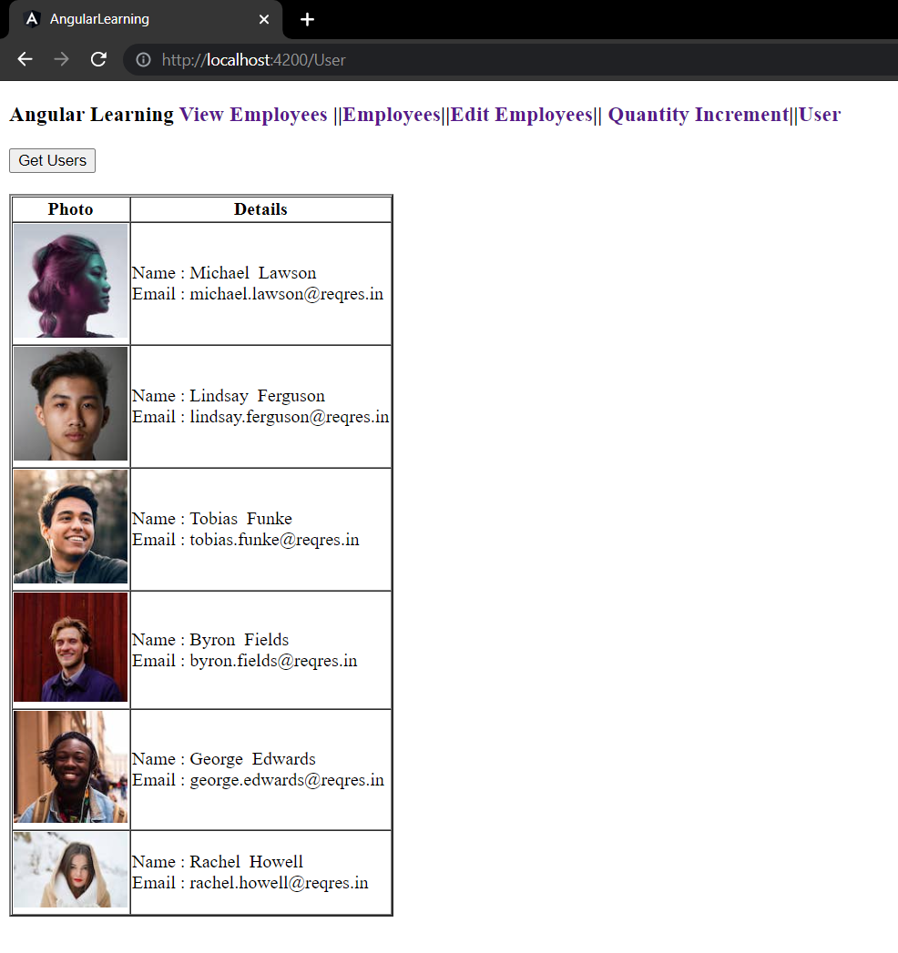**OUTPUT:**

**Session - 2**

1. **Demonstrate end to end testing using Protractor**

**todo-spec.js**

describe('angularjs homepage todo list', function() {

it('should add a todo', function() {

    browser.get('https://angularjs.org');

    element(by.model('todoList.todoText')).sendKeys('write first protractor test');

    element(by.css('[value="add"]')).click();

    var todoList = element.all(by.repeater('todo in todoList.todos'));

    expect(todoList.count()).toEqual(3);

    expect(todoList.get(2).getText()).toEqual('write first protractor test');

    // You wrote your first test, cross it off the list

    todoList.get(2).element(by.css('input')).click();

    var completedAmount = element.all(by.css('.done-true'));

    expect(completedAmount.count()).toEqual(2);

    });

});

**conf.js**

exports.config =

{

    seleniumAddress: 'http://localhost:4444/wd/hub',

    specs: ['todo-spec.js']

};

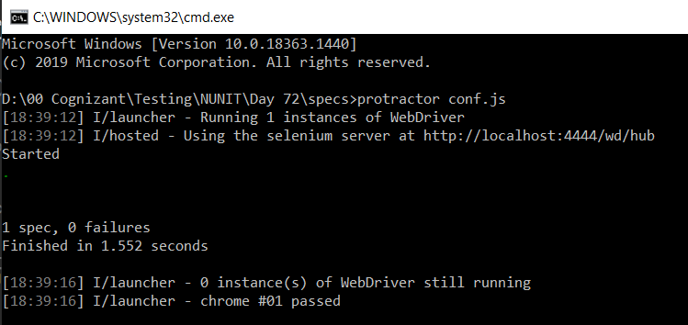

**OUTPUT:**